1) The apropos command allows you to search the system’s manual pages for commands
that match a specific task or keyword. This is particularly useful when you need to find
a command that performs a specific task but you don’t know the name of the command.
Try the following and display the output in your lab document.
(i) apropos "search for files"
(ii) apropos "list directory contents". Another way to get the same output is
apropos "^list.*directory" (note the use of wildcards here). The ^ denotes
that there is no other character before the word ‘list’ in the search.
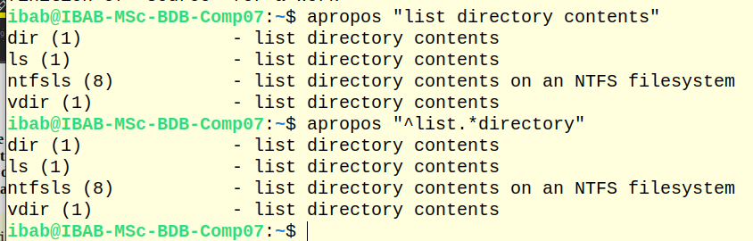
(iii) apropos "file compress"

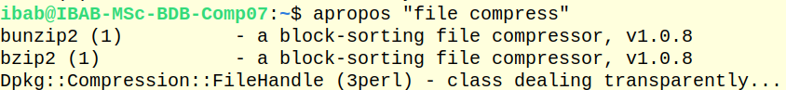
(iv) apropos "file.*copy$" (The $ denotes that there is no character to be searched
after the word ‘copy’.
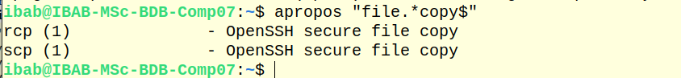
Come up with 3 more keywords/phrases that you can try for this command and got
meaningful output (show the screenshots of all your outputs)
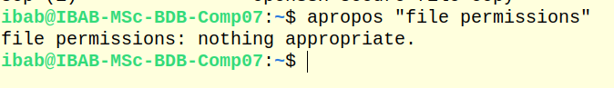

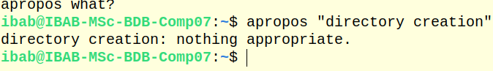

(2) File permisisons. Try the following exercises and explain the output in your work.
(i) touch newfile followed by ls a-l newfile. Describe the permissions set for the
user, group and everyone else.
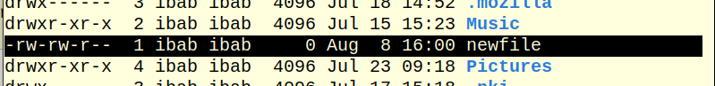
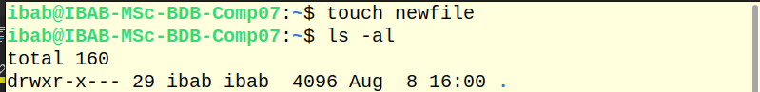

- --means regular file , however d means directory
rw- permission for the owner (user) -read and write
rw- permission for the group -read and write--
r-- permission for others -read only

(ii) Print the output of umask command. Explain what is the actual level of default
permission based on this output for a file, and for a directory

for files it is 666
for directories it is 777
and our umask value is 0002

(iii) Create a new file in your Lab7 directory and print and explain the current per-
missions for the file. Write down the octal values for the user, group and everyone
else

- --means regular file , however d means directory
rw- permission for the owner (user) -read and write
rw- permission for the group -read and write--
r-- permission for others -read only
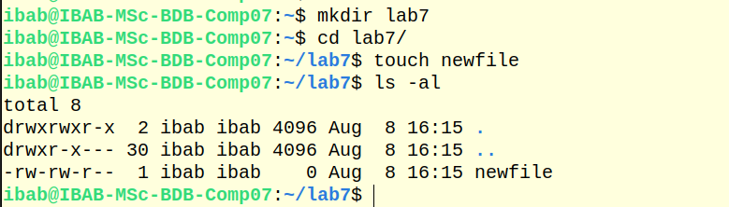

octal values for the user(6), group(6) and everyone(4) else

(iv) Create a new directory in your Lab7 directory and print and and explain the current
permissions for the file. Write down the octal values for the user, group and everyone
else.
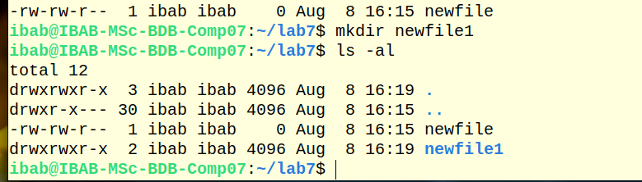
octal values for the user(7), group(7) and everyone(5) else

(v) Copy the new file from above to the new directory and list the permissions of the
file inside the directory. Is it the same as the file outside the directory? What does
this tell you about the copying action?
There is no change in the permission and it is the same file inside the new directory

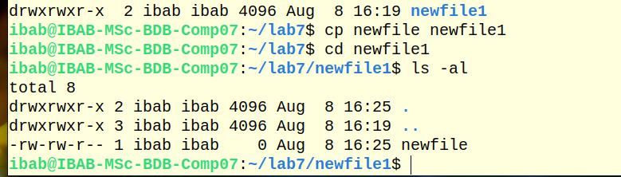
(vi) Change the permissions of the directory such that it is only readable and writable and executable by the user and the group, and only readable by everyone else. What happens to
the permissions of the file inside the directory? Does it inherit the new permissions
you just set? What are the new octal values for the directory permissions?
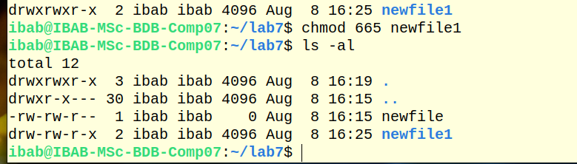
New octal value for the directory is 665
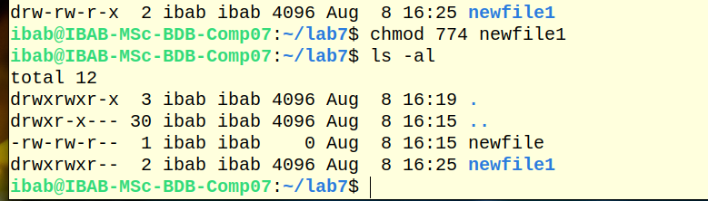
now octal value for the directory is 774 which is only readable and writable and executable by the user and the group, and only readable by everyone else

(vii) Move the above-created new file to the new directory under a different name. Does
the moving action change the file permissions
moving the newfile to the new directory under a different name didnt cahnge any permissions
